Short Questions:
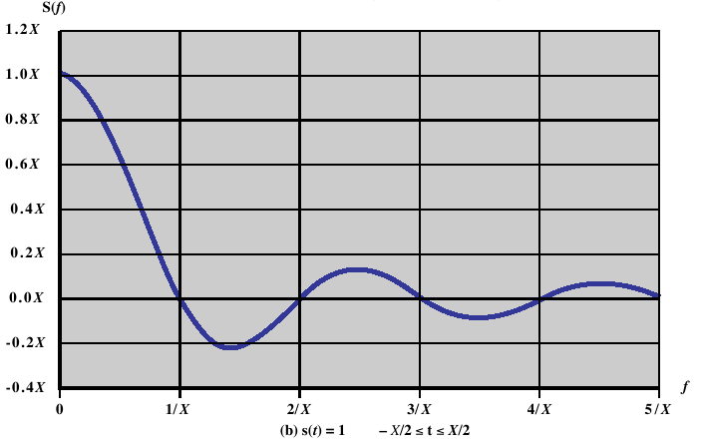Figure 1: Frequency Domain Representation.

- Differentiate between guided media and unguided media.
- Differentiate between an analog and a digital electromagnetic signal.
- What are three important characteristics of a periodic signal.
- What is the relationship between the wavelength and frequency of a sine wave.
- Define fundamental frequency.
- What is the relationship between a signal's spectrum and its bandwidth.
- What is attenuation?
- Define channel capacity.
- What key factors affect channel capacity?

Problems:

- Figure 1 shows the frequency domain function for a single square pulse. The signal pulse could represent a digital 1 in a communications system. Note that an infinite number of higher frequencies of decreasing magnitudes is needed to represent the single pulse. What implication does that have for a real digital transmission system?

  - Suppose that a digitised TV picture is to be transmitted from a source that uses a matrix of 480 x 500 picture elements (pixels), where each pixel can take on one of 32 intensity values. Assume that 30 pictures are sent per second. (This digital source is is roughly equivalent to broadcast TV standards that have been adopted.) Find the source rate R (bps)
  - Assume that the TV picture is to be transmitted over a channel with 4.5Mhz bandwidth and a 35dB signal-to -noise ratio. Find the capacity of the channel (bps).
  - Discuss how the parameters given in part (a.) could be modified to allow transmission of colour TV signals without increasing the required value for R.
- What is the channel capacity for a teleprinter channel with a 300Hz bandwidth and a signal-to-noise ratio of 3dB, where the noise is white thermal noise?
- A digital signalling system is required to operate at 9600bps.
  - If a signal element encodes a 4-bit word, what is the minimum required bandwidth of the channel?
  - Repeat part (a.) for the case of 8-bit words.
- Given the narrow (usable) audio bandwidth of a telephone transmission facility, a nominal SNR of 56dB (400,000), and a certain level of distortion,
  - What is the theoretical maximum channel capacity (kbps) of traditional telephone lines?
  - What can we say about the actual maximum channel capacity?
- Given a channel with an intended capacity of 20Mpbs, the bandwidth of the channel is 3MHz. Assuming white thermal noise, what signal-to-noise ratio is required to achieve this capacity?
- If an amplifier has a 30dB voltage gain, what voltage ratio does the gain represent?
- An amplifier has an output of 20W. What is the output in dBW?
Answers:

Short Questions

- With guided media, the electromagnetic waves are guided along an enclosed physical path whereas unguided media provide a means for transmitting electromagnetic waves but do not guide them.
- A continuous or analog signal is one in which the signal intensity varies in a smooth fashion over time while a discrete or digital signal is one in which the signal intensity maintains one of a finite number of constant levels for some period of time and then changes to another constant level.
- Amplitude, frequency, and phase are three important characteristics of a periodic signal.
- The relationship is λf = v, where λ is the wavelength, f is the frequency, and v is the speed at which the signal is traveling.
- The fundamental frequency is the lowest frequency component in the Fourier representation of a periodic quantity.
- The spectrum of a signal is the frequencies it contains while the bandwidth of a signal is the width of the spectrum.
- Attenuation is the gradual weakening of a signal over distance.
- The rate at which data can be transmitted over a given communication path, or channel, under given conditions, is referred to as the channel capacity.
- Bandwidth, noise, and error rate.

Problems

- No transmission medium is capable of transmitting the entire spectrum of frequencies. A real signal therefore is bandlimited, with frequencies above a certain point absent. However, most of the information is in the lower frequencies. This is not a problem if it is remembered that the object of the transmission is to send signals that represent binary 1s and 0s. Even though there will be some distortion because of the loss of higher frequencies, the shape of the original pulse is known (by the specifications for the transmission system). Thus, the receiver will usually be able to distinguish a binary 0 from a binary 1.

  - (30 pictures/s) (480 × 500 pixels/picture) = 7.2 × 10⁶ pixels/s
Each pixel can take on one of 32 values and can therefore be represented by 5 bits:
R = 7.2 × 10⁶ pixels/s × 5 bits/pixel = 36 Mbps
  - We use the formula: C = B log₂ (1 + SNR)
B = 4.5 × 10⁶ Hz = bandwidth, and
SNR_{dB} = 35 = 10 log₁₀ (SNR), hence
SNR = 10^{35/10} = 10^{3.5}, and therefore
C = 4.5 × 10⁶ log₂ (1 + 10^{3.5}) = 4.5 × 10⁶ × log ₂ (3163)
C = (4.5 × 10⁶ × 11.63) = 52.335 × 10⁶ bps
  - Allow each pixel to have one of ten intensity levels and let each pixel be one of three colors (red, blue, green) for a total of 10 × 3 = 30 levels for each pixel element.
- Using Shannon's equation: C = B log₂ (1 + SNR)
We have W = 300 Hz (SNR)_{dB} = 3
Therefore, SNR = 10^{0.3}
C = 300 log₂ (1 + 10^{0.3}) = 300 log₂ (2.995) = 474 bps
- Using Nyquist's equation: C = 2B log₂M
We have C = 9600 bps
  - log₂ M = 4, because a signal element encodes a 4-bit word
Therefore, C = 9600 = 2B × 4, and B = 1200 Hz
  - 9600 = 2B × 8, and B = 600 Hz

  - Using Shannon’s formula: C = 3000 log₂ (1+400000) = 56 Kbps
  - Due to the fact there is a distortion level (as well as other potentially detrimental impacts to the rated capacity, the actual maximum will be somewhat degraded from the theoretical maximum. A discussion of these relevant impacts should be included and a qualitative value discussed.
- C = B log₂ (1 + SNR)
20 × 10⁶ = 3 × 10⁶ × log₂ (1 + SNR)
log₂ (1 + SNR) = 6.67
1 + SNR = 102
SNR = 101
- For a voltage ratio, we have
N_{dB} = 30 = 20 log(V₂ /V₁ )
V₂ /V₁ = 10^{30/20} = 10^{1.5} = 31.6
- Power (dBW) = 10 log (Power/1W) = 10 log20 = 13 dBW

